**BineryReader**

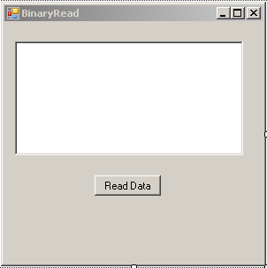

Imports System.IO

Public Class BinaryRead

Private Sub Button1_Click(ByVal sender As System.Object, ByVal e As System.EventArgs) Handles Button1.Click

Try

Dim fs As New FileStream("D:\UserData", FileMode.Open, FileAccess.Read)

Dim binaryRead As New BinaryReader(fs)

While (binaryRead.PeekChar <> -1)

RichTextBox1.Text = RichTextBox1.Text & binaryRead.ReadString() & " | "

End While

binaryRead.Close()

Catch ex As Exception

MsgBox(ex.Message)

End Try

End Sub

End Class